Anomaly detection in hourly building electricity meter data
  - Unsupervised and supervised machine learning evidence

EDAB6808 Assignment 2
Lwazi Nhlapo(2021856345)

Fumane Malangabe(2019611165)

Executive summary
The results support a tuned LightGBM classifier as the preferred detector for the unlabelled test buildings. In five-fold validation that holds out 40 whole buildings at a time, LightGBM reaches a mean precision-recall area under the curve (PR-AUC) of 0.7765, compared with 0.5086 for a tuned Isolation Forest. PR-AUC measures how precise the flagged hours remain as more of the true anomalies are recovered. A model that ranked hours at random would score about 0.0227, the share of modelled hours labelled anomalous. LightGBM also has the higher receiver operating characteristic area under the curve (ROC-AUC), 0.9542 against 0.8994, and it leads on both measures in all five held-out groups of buildings.
At the selected score threshold of 0.9795, LightGBM's out-of-fold predictions reach a precision of 0.8603, a recall of 0.6421 and an F1 score of 0.7353. About 86 of every 100 flagged hours are labelled anomalies, and about 64 of every 100 labelled anomalies are found. The threshold favours precision: it produces 3,888 false alarms and 13,350 missed anomalies. The default threshold of 0.5 would recover 80.08% of anomalies, but fewer than half of its flags would be correct (precision 0.4430). Applied to test.csv, the final model flags 1.4280% of rows, and the submission file matches the 1,800,567-row template.
The largest driver of performance is a feature rather than the choice of model or tuning method. Labelled anomalies repeat the previous hour's exact reading 62.0% of the time, compared with 9.4% of normal hours. The run-length feature built on this pattern is the largest single source of LightGBM gain, and with its companion flag it carries 41.5% of total gain. Bayesian tuning changed little. LightGBM moved from 0.7799 with hand-picked settings to 0.7765, and Isolation Forest from 0.4877 to 0.5086. Both changes are small relative to the fold-to-fold standard deviations of 0.0642 and 0.1081, so tuning added a documented, repeatable search rather than a clear improvement.

Purpose and scope
Question 1 requires anomaly detection on hourly building electricity meter readings, a validation design that prevents leakage, at least ten explained point anomalies and binary predictions for the unlabelled test file in the sample-submission format (University of the Free State, 2026). The data are a subset of the Large-scale Energy Anomaly Detection (LEAD) competition data (Kaggle, n.d.), an annotated release of hourly electricity meter series from the ASHRAE Great Energy Predictor III data (Gulati and Arjunan, 2022).
The analysis uses train.csv and test.csv only; the brief allows full marks without the optional feature files, and building every feature in the notebook keeps each step auditable. The test predictions are model outputs, not confirmed faults.

2 Data preparation and the detection target
The training file contains 1,749,494 hourly rows for 200 buildings, covering every hour of 2016. Each row holds building_id, timestamp, meter_reading and anomaly, where anomaly = 1 marks an hour labelled anomalous. The test file has 1,800,567 rows with a row_id in place of the label, and sample_submission.csv lists the same row_id values.
Table 1. Data checks and cleaning decisions
Check | Result | Decision
Duplicate building-hour pairs | 0 | No de-duplication needed
Hours absent from the file | 7,306 of 1,756,800 building-hours; median 1 and maximum 1,313 per building | Reinserted as empty hours so that lags follow clock time
Rows with no reading | 107,653 (6.15%), all labelled normal | Not imputed or scored; missing share kept as a feature
Buildings with missing readings | 177 of 200; 2 have more than half missing | Buildings kept
Labelled anomalies | 2.1318% of all rows; 2.2716% of rows with a reading | Accuracy not used; PR-AUC is the main measure
Modelling frame | 1,641,841 rows, 24 features | Used for all validation

Missing data take two forms. First, 7,306 of the 1,756,800 building-hours in a full 2016 calendar are absent from the file. They are reinserted as empty rows; otherwise the previous hour after a gap would be a reading from hours or days earlier, and the change and run-length features would be wrong. Second, 107,653 rows are present with no reading, and every one is labelled normal. A missing reading is therefore treated as a data-quality issue, not an anomaly; these rows are not imputed or scored, and the missing share in a centred 24-hour window (miss_24) is kept as a predictor.
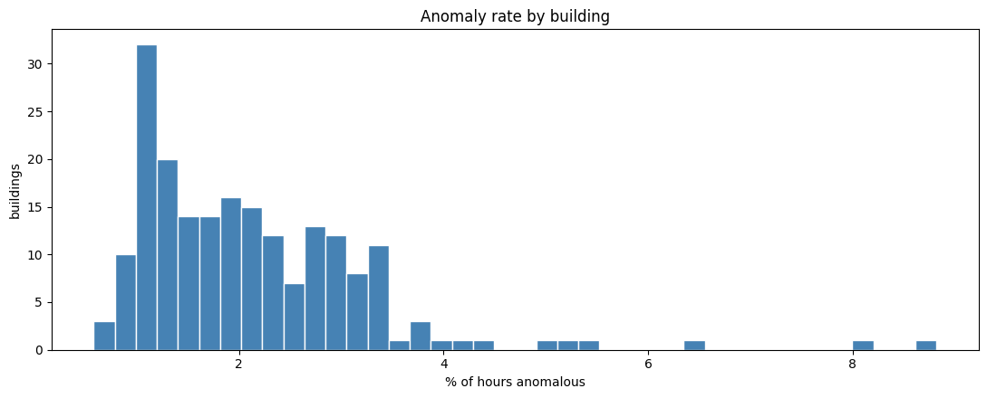
Figure 1. Share of hours labelled anomalous in each training building.
Labelled anomalies are rare: 37,296 of 1,749,494 rows (2.1318%), about 43 normal hours for every anomalous hour among rows with a reading. A rule that labels every hour normal would be 97.87% accurate and detect nothing, so accuracy is not used. Figure 1 shows that the anomaly share ranges from 0.58% to 8.82% across buildings. A model that has seen some hours of a building learns that building's level, noise and faults, so evaluation must hold out whole buildings to reflect performance on the new buildings in the test file (Section 4).

3 What the exploratory analysis implies
Figure 2 plots building 1319, the building with the most labelled anomalous hours. The labels cover at least three visible patterns: drops to zero, short spikes above the usual range, and long flat stretches, such as those in November and late December. The gap from mid-May to early June has no readings and is not an anomaly. An anomaly is therefore defined by behaviour over several hours, not only by the size of one reading.
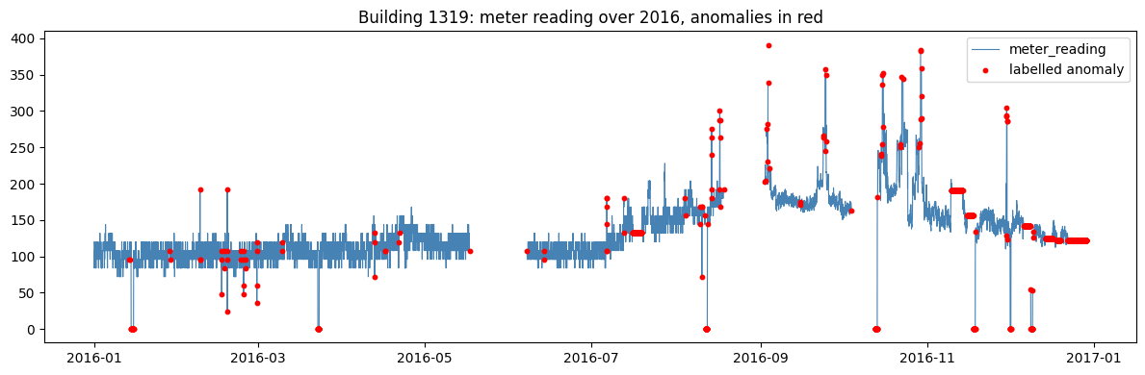
Figure 2. Building 1319 meter readings during 2016, with labelled anomalies in red.
Table 2. Mean feature values by class, selected features
Feature | Meaning | Normal (0) | Anomalous (1)
same_prev | Share of hours equal to the previous hour | 0.094 | 0.620
run_len | Consecutive hours with an unchanged reading | 1.302 | 11.886
z | Standard deviations from the building mean | 0.035 | −1.512
ratio_med | Reading divided by the building median | 1.204 | 0.630
dev_prof | Deviation from the usual hour-of-week level | 0.024 | −1.487
miss_24 | Missing share in the centred 24-hour window | 0.003 | 0.040
hour | Hour of day | 11.509 | 11.202
wknd | Weekend share | 0.286 | 0.279

Means are taken over the 1,641,841 rows with a reading.
The flatline pattern is the clearest single difference. Anomalous hours repeat the previous reading 62.0% of the time, against 9.4% for normal hours, and their average run of unchanged readings is 11.9 hours rather than 1.3. Anomalous readings also sit below their building's usual level, with a mean z-score of −1.512 and a mean ratio to the building median of 0.630, against 1.204 for normal hours. Low and stuck readings dominate the labelled anomalies on average, even though Figure 2 shows that spikes are also labelled.
Calendar features barely differ between the classes, so the timing of an hour alone would not identify anomalies. The missing share near anomalous hours is higher (0.040 against 0.003), which is consistent with faults that also interrupt data collection. These are averages and are sensitive to extreme values; Section 7 uses the fitted model to judge which features separate individual hours.

4 Methodology and leakage-safe validation
The test file contains different buildings from the training file, so validation must measure performance on buildings the model has not seen. The notebook uses GroupKFold with building_id as the group, which places each building in exactly one validation fold (scikit-learn, n.d.a). Each fold trains on 160 buildings, about 1.31 million rows, and validates on the other 40, with zero overlap confirmed in every fold. A random split of rows would be misleading: anomalies occur in runs, so hours from the same episode would fall on both sides of the split, and a model could score well by recognising an episode it had already seen.
Table 3. Validation structure used in the notebook
Stage | Data used | Purpose
Outer split | 5 folds by building; 160 training and 40 validation buildings per fold | Estimate performance on unseen buildings
Inner split | Each outer training fold split 80/20 by building (128 and 32 buildings) | Hyperparameter search only
Search | 12 Gaussian-process trials per model per fold; inner training rows subsampled to 300,000 | Choose settings by inner-validation PR-AUC
Outer refit | Chosen settings refitted on the full outer training fold | Score the 40 held-out buildings
Threshold | Pooled out-of-fold LightGBM scores for 1,641,841 rows | Convert scores to 0 or 1 at maximum F1
Final model | Fold 2 settings refitted on all 200 buildings | Score test.csv

Each outer fold runs its own search on its training buildings only, so the 40 outer-validation buildings play no part in choosing that fold's settings. This nested design keeps the outer scores from being inflated by tuning on the data used to report them (Cawley and Talbot, 2010).

How label and building information is kept out
Every feature for an hour is built from that building's own readings, never from another building or the label; the notebook asserts that neither row_id nor anomaly is in the feature list. Four features (dev24, rat24, dev168 and rat168) use centred windows that include hours after hour t. This suits the task, which reviews a completed year for each building in the way an auditor would review a finished meter record, but a real-time system would need windows that use past hours only.

Limits of the evaluation design
The threshold is chosen on the same out-of-fold predictions used to report precision, recall and F1, so those figures are mildly optimistic; PR-AUC and ROC-AUC do not depend on a threshold. The final settings come from the fold with the highest outer PR-AUC, so the fold mean remains the fairer estimate for new buildings. Hours are also not independent: the 37,296 labelled hours form far fewer separate episodes, and fold scores depend on which buildings are held out. Finally, the threshold is set on scores from five differently tuned fold models but applied to one model refitted on all buildings, and the notebook does not test that transfer.

5 Feature engineering and model development

Features built around the flatline pattern
The notebook builds 24 features per building-hour: level relative to the building (z, rz, ratio_med, log_r); the flatline pair (same_prev, run_len); changes from 1, 24 and 168 hours earlier (d1, p1, d24, p24, d168, p168); deviation from local and usual behaviour (dev24, rat24, dev168, rat168, dev_prof, dev_hr); and calendar and data-quality terms (hour, dow, month, doy, wknd, miss_24). The run length is defined as:
$$r_{b,t}=\left\{\begin{aligned}r_{b,t−1}+1, if x_{b,t}=x_{b,t−1} \\ 1, otherwise\end{aligned}\right.$$
Here, $x_{b,t}$ is the reading of building b in hour t, and $r_{b,t}$ is the number of consecutive hours, up to and including hour t, with an unchanged reading; it is 0 when the reading is missing. same_prev equals 1 exactly when $r_{b,t}$ is 2 or more, so it adds nothing once run_len is present. Because the count runs backwards, a flatline is only flagged after several hours. Deviation features compare a reading with its surroundings: ${dev}_{W,t}=(x_{b,t}−m_{W,t})/s_{W,t}$, where m and s are the centred W-hour rolling mean and standard deviation.

Isolation Forest scores unusualness without labels
Isolation Forest splits the feature space at random and treats hours isolated after few splits as more unusual (Liu, Ting and Zhou, 2008). It does not see the labels, so it tests how far unusualness alone matches the annotated anomalies. Of its four searched settings, contamination only sets the cut-off used by the predict method and does not change score_samples, which the notebook uses as the score (scikit-learn, n.d.b). It has no effect on PR-AUC, so only the number of trees, rows per tree and share of features are effectively tuned.

LightGBM learns from the labelled anomalies
LightGBM builds gradient-boosted trees, each correcting the errors of those before it, and learns from the labels (Ke et al., 2017). The class weight (scale_pos_weight) equals the ratio of normal to anomalous hours in each training fold, about 43 overall, so a missed anomaly costs far more in training than a false alarm. The search covers the learning rate, leaves per tree, minimum rows per leaf, and row and column sampling. Row sampling only takes effect when subsample_freq is above zero, which the notebook leaves at 0 (LightGBM, n.d.), so four settings are effectively tuned.

Bayesian search replaces hand-picked settings
Both searches use a Gaussian-process model with a Matérn kernel and expected improvement, implemented with scikit-learn: four random trials, then eight chosen from a fixed pool of 1,024 candidates (Snoek, Larochelle and Adams, 2012). Twelve trials is a small budget. The inner scores were also a weak guide: fold 1 had the highest inner LightGBM score (0.7854) but the lowest outer PR-AUC (0.6789), because 32 inner-validation buildings give a noisy score.

6 Model comparison under the same design
Every training hour receives one out-of-fold score from each model. Precision is TP / (TP + FP) and recall is TP / (TP + FN), where TP, FP and FN count true positives, false positives and false negatives. PR-AUC is computed as average precision (AP):
$$AP=\sum_{n}{(R_{n}−R_{n−1})P_{n}}$$
Here, hours are ranked by score, n indexes each successive threshold, $P_{n}$ and $R_{n}$ are the precision and recall when every hour at or above it is flagged, and $R_{n}−R_{n−1}$ is the recall added (scikit-learn, n.d.c). A random ranking gives an AP close to the anomaly share, 0.0227. ROC-AUC, the chance that an anomalous hour outscores a normal one, can look high even when many flags are false, so PR-AUC is the main measure (Saito and Rehmsmeier, 2015).
Table 4A. Outer-fold results on 40 held-out buildings per fold
Fold | LightGBM  inner AP | LightGBM  PR-AUC | LightGBM  ROC-AUC | IF  inner AP | IF  PR-AUC | IF  ROC-AUC
0 | 0.7178 | 0.8146 | 0.9709 | 0.4221 | 0.5780 | 0.9179
1 | 0.7854 | 0.6789 | 0.9315 | 0.5286 | 0.3435 | 0.8632
2 | 0.7332 | 0.8338 | 0.9733 | 0.5287 | 0.5947 | 0.9328
3 | 0.7623 | 0.7445 | 0.9467 | 0.5073 | 0.4535 | 0.8906
4 | 0.7677 | 0.8109 | 0.9488 | 0.5277 | 0.5735 | 0.8924
Mean | 0.7533 | 0.7765 | 0.9542 | 0.5029 | 0.5086 | 0.8994

Table 4B. Summary across folds and comparison with hand-picked settings
Model | Mean  PR-AUC | SD  PR-AUC | Pooled OOF  PR-AUC | Mean  ROC-AUC | Hand-picked  PR-AUC (SD)
LightGBM (tuned) | 0.7765 | 0.0642 | 0.7695 | 0.9542 | 0.7799 (0.0616)
Isolation Forest (tuned) | 0.5086 | 0.1081 | 0.4930 | 0.8994 | 0.4877 (0.0856)
Random ranking | 0.0227 | n/a | 0.0227 | 0.5000 | n/a

IF is Isolation Forest and OOF is out-of-fold. Hand-picked scores come from an earlier run and are not recomputed in the saved notebook.
LightGBM ranks first on PR-AUC and ROC-AUC in every fold. Its mean PR-AUC is 52.7% higher than that of Isolation Forest and about 34 times the random baseline, and its fold standard deviation is lower (0.0642 against 0.1081). Isolation Forest still scores about 22 times the baseline, so unusualness alone is informative, but without labels it cannot tell which unusual hours the annotators marked.
Tuning changed mean PR-AUC by −0.0034 (−0.4%) for LightGBM and +0.0209 (+4.3%) for Isolation Forest, both smaller than one fold standard deviation. Per-fold hand-picked scores are not saved, so a paired test is not possible; the search's value is a documented, repeatable process rather than a proven gain.

7 Threshold choice and feature diagnostics
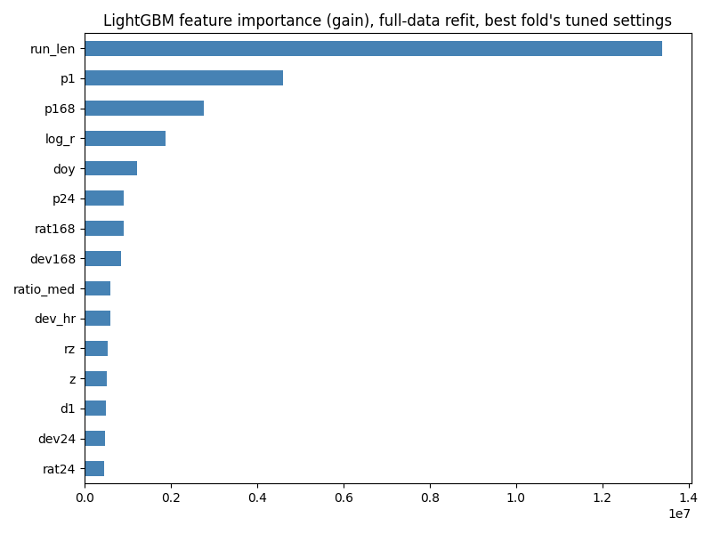
Figure 3. LightGBM feature importance by total gain, top 15 features, refitted on all training data with fold 2 settings.
Figure 3 confirms the flatline result. run_len is the largest source of gain, close to three times the next feature, the one-hour percentage change (p1). same_prev is absent because run_len already holds its information, and the two carry 41.5% of total gain. Day of year (doy) ranks fifth, which may reflect dates when faults hit several buildings at once (Section 8); that would not carry over to another year. Gain shows use in the trees, not causation.

Choosing the decision threshold
The threshold is set where F1, the harmonic mean of precision and recall, $F1=2PR/(P+R)$, is highest on the pooled out-of-fold scores. Table 5 compares that choice with the default of 0.5.
Table 5A. LightGBM out-of-fold performance at two thresholds
Threshold | Precision | Recall | F1
0.9795 (maximum F1) | 0.8603 | 0.6421 | 0.7353
0.5000 (default) | 0.4430 | 0.8008 | 0.5705

Table 5B. Confusion matrix at the 0.9795 threshold
 | Predicted normal | Predicted anomaly
Actual normal | 1,600,657 | 3,888
Actual anomaly | 13,350 | 23,946

Raising the threshold from 0.5 to 0.9795 lifts precision from 0.4430 to 0.8603 and F1 from 0.5705 to 0.7353 at the cost of recall, and flags 27,834 hours (1.70%) against a true anomaly share of 2.27%. The threshold is not a 98% probability: the class weight of about 43 pushes scores upward, so they rank well but are not calibrated. For a facilities team, a false alarm costs inspection time while a missed stuck meter leaves consumption unrecorded or wrongly billed; a team able to review more flags would lower the threshold.

8 Point anomalies and test-set predictions
Table 6 lists the ten labelled anomalies with the highest out-of-fold LightGBM scores and the features that explain them. All ten score 1.000 to three decimals.
Table 6. Ten highest-scoring labelled anomalies
Building | Timestamp | Reading | z | run_len | dev24 | dev_prof
903 | 2016-02-24 01:00 | 1.0 | −8.352 | 15 | −0.209 | −7.924
903 | 2016-02-24 02:00 | 1.0 | −8.352 | 16 | −0.302 | −7.897
903 | 2016-02-24 03:00 | 1.0 | −8.352 | 17 | −0.379 | −7.842
903 | 2016-02-24 04:00 | 1.0 | −8.352 | 18 | −0.449 | −7.815
903 | 2016-02-24 05:00 | 1.0 | −8.352 | 19 | −0.515 | −7.788
879 | 2016-02-24 01:00 | 1.0 | −7.789 | 15 | −0.209 | −7.510
879 | 2016-02-24 02:00 | 1.0 | −7.789 | 16 | −0.302 | −7.557
879 | 2016-02-24 03:00 | 1.0 | −7.789 | 17 | −0.379 | −7.557
879 | 2016-02-24 04:00 | 1.0 | −7.789 | 18 | −0.449 | −7.557
1302 | 2016-01-21 01:00 | 1.0 | −4.056 | 9 | −0.755 | −3.786

All ten rows have same_prev = 1.
Each reading has been unchanged for 9 to 19 hours and sits 4.1 to 8.4 standard deviations below its building's annual mean and 3.8 to 7.9 below its usual level for that hour of the week. By contrast, dev24 ranges only from −0.21 to −0.76: the centred 24-hour window is dominated by the flat stretch, so each reading looks ordinary against its neighbours. Rolling-window features alone would miss long flatlines, which is why run length and building-level features matter.
The ten rows are three episodes, not ten independent events. Buildings 879 and 903 both read exactly 1.0 in every listed hour on 24 February 2016, and their run lengths show that both flat runs began at 11:00 on 23 February; building 1302's began at 17:00 on 20 January. Identical readings and identical dev24 values in two buildings over the same hours point to a shared logging or transmission fault rather than two equipment failures, although the data cannot confirm this. The zeros and spikes in Figure 2 are not represented.

Test-set predictions
The final model uses the fold 2 settings, which had the highest outer PR-AUC, refitted on all 1,641,841 modelled hours. Test hours with a reading (1,705,703) that score at or above 0.9795 are labelled 1, and the 94,864 rows without a reading are labelled 0, since every missing training reading is normal. row_id is used only for the join. The saved anomaly_submission.csv has 1,800,567 rows (row_id, anomaly), and the notebook confirms the row count, unique IDs and binary labels. It flags 1.4280% of test rows, about 1.51% of those with a reading, slightly below the 1.70% flagged out of fold; the gap cannot be checked without test labels.

9 Interpretation, uncertainty and conclusion
A flagged hour is one whose reading resembles the labelled anomalies, most strongly a reading that has stopped changing while sitting far from the building's usual level. In practice, such a pattern can come from a stuck meter register, a data logger repeating its last value during a communication fault, or a genuinely constant load. The first two are data faults that would distort billing, benchmarking and energy-saving analysis; the third is not a fault. The model cannot separate these causes, so flagged hours are candidates for review, not confirmed faults. Finding them still serves the energy-saving goal that motivated the LEAD dataset (Gulati and Arjunan, 2022).

How to read the scores
Model scores are rankings, not probabilities. The threshold of 0.9795 is a cut-off chosen to balance precision and recall on the training buildings, and its F1 of 0.7353 is measured on the same predictions used to choose it. The mean PR-AUC of 0.7765 across held-out buildings is the more reliable summary of how well the model will rank anomalies in new buildings, and the fold range from 0.6789 to 0.8338 shows how much that can vary with the buildings involved.

Conclusion and limits of the recommendation
LightGBM is the most defensible choice among the tested models. It leads on PR-AUC and ROC-AUC in every held-out fold and varies less across folds than Isolation Forest. Isolation Forest is useful as a label-free check, but it recovers far less of the labelled anomaly pattern. The clearest finding is that the run-length feature matters more than the choice of model or the tuning method.
Several limits remain. The model learns the annotators' definition of an anomaly, so any hours they missed or mislabelled are learnt as given. Centred windows and full-year building profiles require a completed year of data; a real-time system would need past-only features and may lose accuracy. Date features and the selected settings are tied to 2016 and to these buildings, so performance in another year is untested. Missing test readings are labelled normal by rule rather than by the model. Finally, the search used 12 trials on a 300,000-row subsample, with contamination and row sampling inactive. A wider search could still change the settings, although the small differences in Table 4B suggest that large gains are unlikely.

References
Cawley, G. C. and Talbot, N. L. C. (2010). On over-fitting in model selection and subsequent selection bias in performance evaluation. Journal of Machine Learning Research, 11, pp. 2079–2107.
https://www.jmlr.org/papers/v11/cawley10a.html
Gulati, M. and Arjunan, P. (2022). LEAD1.0: A large-scale annotated dataset for energy anomaly detection in commercial buildings. arXiv:2203.17256.
https://arxiv.org/abs/2203.17256
Kaggle (n.d.). Large-scale Energy Anomaly Detection (LEAD). Competition page.
https://www.kaggle.com/competitions/energy-anomaly-detection
Ke, G., Meng, Q., Finley, T., Wang, T., Chen, W., Ma, W., Ye, Q. and Liu, T.-Y. (2017). LightGBM: A highly efficient gradient boosting decision tree. Advances in Neural Information Processing Systems 30.
https://papers.nips.cc/paper/2017/file/6449f44a102fde848669bdd9eb6b76fa-Paper.pdf
LightGBM (n.d.). Parameters. Official documentation.
https://lightgbm.readthedocs.io/en/latest/Parameters.html
Liu, F. T., Ting, K. M. and Zhou, Z.-H. (2008). Isolation forest. Proceedings of the Eighth IEEE International Conference on Data Mining, pp. 413–422.
https://doi.org/10.1109/ICDM.2008.17
Saito, T. and Rehmsmeier, M. (2015). The precision-recall plot is more informative than the ROC plot when evaluating binary classifiers on imbalanced datasets. PLOS ONE, 10(3), e0118432.
https://doi.org/10.1371/journal.pone.0118432
scikit-learn (n.d.a). GroupKFold. Official API documentation.
https://scikit-learn.org/stable/modules/generated/sklearn.model_selection.GroupKFold.html
scikit-learn (n.d.b). IsolationForest. Official API documentation.
https://scikit-learn.org/stable/modules/generated/sklearn.ensemble.IsolationForest.html
scikit-learn (n.d.c). average_precision_score. Official API documentation.
https://scikit-learn.org/stable/modules/generated/sklearn.metrics.average_precision_score.html
Snoek, J., Larochelle, H. and Adams, R. P. (2012). Practical Bayesian optimization of machine learning algorithms. Advances in Neural Information Processing Systems 25.
https://proceedings.neurips.cc/paper/2012/file/05311655a15b75fab86956663e1819cd-Paper.pdf
University of the Free State (2026). EDAB6808 Assignment 2: Anomaly Detection and Forecasting. Question 1, Anomaly Detection. Supplied assignment brief.

